BCS 303 – Security Principles and Practices /
NET220 – Network Security & Administration

Term Project - 15 marks

Summer-I, 2025

Prepared by: Dr. Yasir Faheem

Submission Due on: June 25, 2025
Max Group Size: Up to 3 members / group

Grading Rubrics |  | Unsatisfactory  (1) | Needs Improvement  (2) | Meets Expectations  (3-4) | Exceeds Expectations (5)
1 | Apply security measures against threats to maintain the system operation. | Fails to implement or recognize essential security measures, leaving vulnerabilities unaddressed. | Applies some security measures but inconsistently or ineffectively. | Effectively implements security protocols, addressing potential threats. | Proactively anticipates security threats, applies advanced techniques, and ensures robust system protection.
2 | Implement a Secure Computer-Based Solution for the Problem to Meet Desired Goals Within Realistic Constraints. | Fails to implement security measures, leading to an unreliable or vulnerable system. | Implements a solution with some security but lacks full adherence to constraints. | Successfully integrates security measures while balancing practical constraints. | Develops a highly secure, efficient, and optimized solution exceeding expectations.

Group Member | Module 1 (5 marks)  Rubric 2 | Module 2 (5 marks)  Rubric 1 | Module 3 (5 marks)  Rubric 1
Name: Hassan Mujtaba

ID: 20220002085

Name : Leanne Jessica Rodrigo

ID : 20210001983

Name: Yasmin Akram Issa

ID: 20230003798

Table of Contents

Module 0: Instruction for Students: Terminal Display Name Change 5
Module 1: Application of Cryptographic Techniques 6
Task 1: Symmetric Encryption & Decryption 6
Task 2: Asymmetric Encryption & Key Exchange 7
Task 3: Implementation of TLS/SSL for Secure Communication 7
Task 4: Ethical Implications of Cryptography 8
Guidelines for Completing Module 1 8
Module 2: Defensive Security against Program & Web Threats 10
Task 1: Buffer Overflow Analysis & Defense 10
Task 2: Multi-Factor Authentication (MFA) Setup using SSH 11
Task 3: Ethical Analysis of Buffer Overflow Defense and MFA 12
Module 3: Operating System Security and Firewall Settings [5 marks] 13
Task 1: Linux System Hardening 13
Task 2: Advanced Firewall Configuration with iptables and Implementing Dynamic Blocked list 13

Introduction
Welcome to an exciting journey into the world of cybersecurity. In today’s digital age, every click, message, or piece of data we share could be a potential target for cyber threats. This project will empower you to protect, defend, and secure computer systems like real-world cybersecurity experts. You will learn how to encrypt sensitive information, thwart program-based attacks, configure firewalls, and apply defensive techniques using powerful tools like Kali Linux.
By completing this project, you'll be developing critical skills that make a difference in securing digital lives. You'll discover how to analyze vulnerabilities, implement robust defenses, and uphold ethical standards in cybersecurity.
Organization: The project is organized in three main modules; module 0 is only to set the display names of group members, but it is a compulsory one. Without setting the terminal to display names of all group members, your project won’t be graded.
Module 1: Application of Cryptographic Techniques
Explore core cryptography by encrypting sensitive data, managing cryptographic keys, and securing communication using TLS/SSL. Develop a strong foundation in data protection while considering ethical implications.
Module 2: Defensive Security against Program & Web Threats
Implement defenses against buffer overflow attacks and enhance access security with Multi-Factor Authentication (MFA). Gain hands-on experience in protecting systems and understand the ethical considerations of defensive measures.
Module 3: Operating System Security and Firewall Settings
Secure Linux systems through hardening measures and advanced firewall configurations using iptables. Build practical skills in managing system and network security while maintaining ethical standards in monitoring.

Grading Criteria:
- Individual Contribution: Each group member will be graded based on their specific contributions to each module. Contributions include technical tasks, documentation, analysis, and participation in discussions related to ethical considerations.

Note: The final grade for each member will depend on their active involvement and evidence of individual contributions throughout the project. This approach ensures fair assessment and accountability for all group members.
Grades will be assigned separately to every group member based on his/her understanding of the project’s implementation, performance in the Q&A session, and quality of the report.

Module 0: Terminal Display Name Change (Compulsory)
To identify group members and ensure individual work, all students must modify their Linux terminal prompt to include the first names of their group members. This will help prevent copying and promote accountability.
Every screenshot must contain the display name of group members. Otherwise, you won’t get any credit for your work.
Step-by-Step Guide
- Open the bash configuration file:
nano ~/.bashrc
- Edit the PS1 variable:
  - Find the line that starts with PS1, or add a new line at the end of the file.
  - Modify it as follows, adding the first names of all group members:
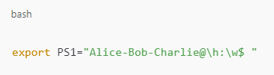
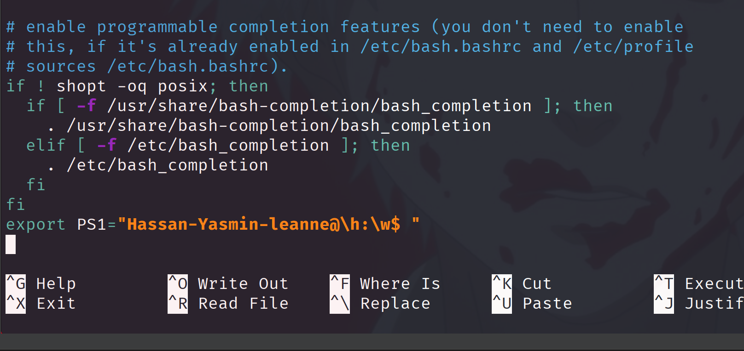
  - Replace Alice, Bob, and Charlie with the actual first names of your group members.
- Save the changes:
  - Press CTRL + X, then Y, and ENTER to save and exit the editor.
- Apply the changes immediately:
  - Run the following command:
source ~/.bashrc
- Verify the new terminal prompt:
  - Open a new terminal session to ensure the prompt displays correctly.
Sample Terminal Output Screenshot
Here’s what the modified terminal should look like:
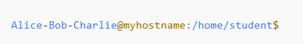
- Alice-Bob-Charlie: Names of group members
- myhostname: System’s hostname
- /home/student: Current working directory
Note: Ensure this format is followed strictly and that it remains active throughout the term project duration.
- Take a screenshot of the terminal window with the modified prompt and output.

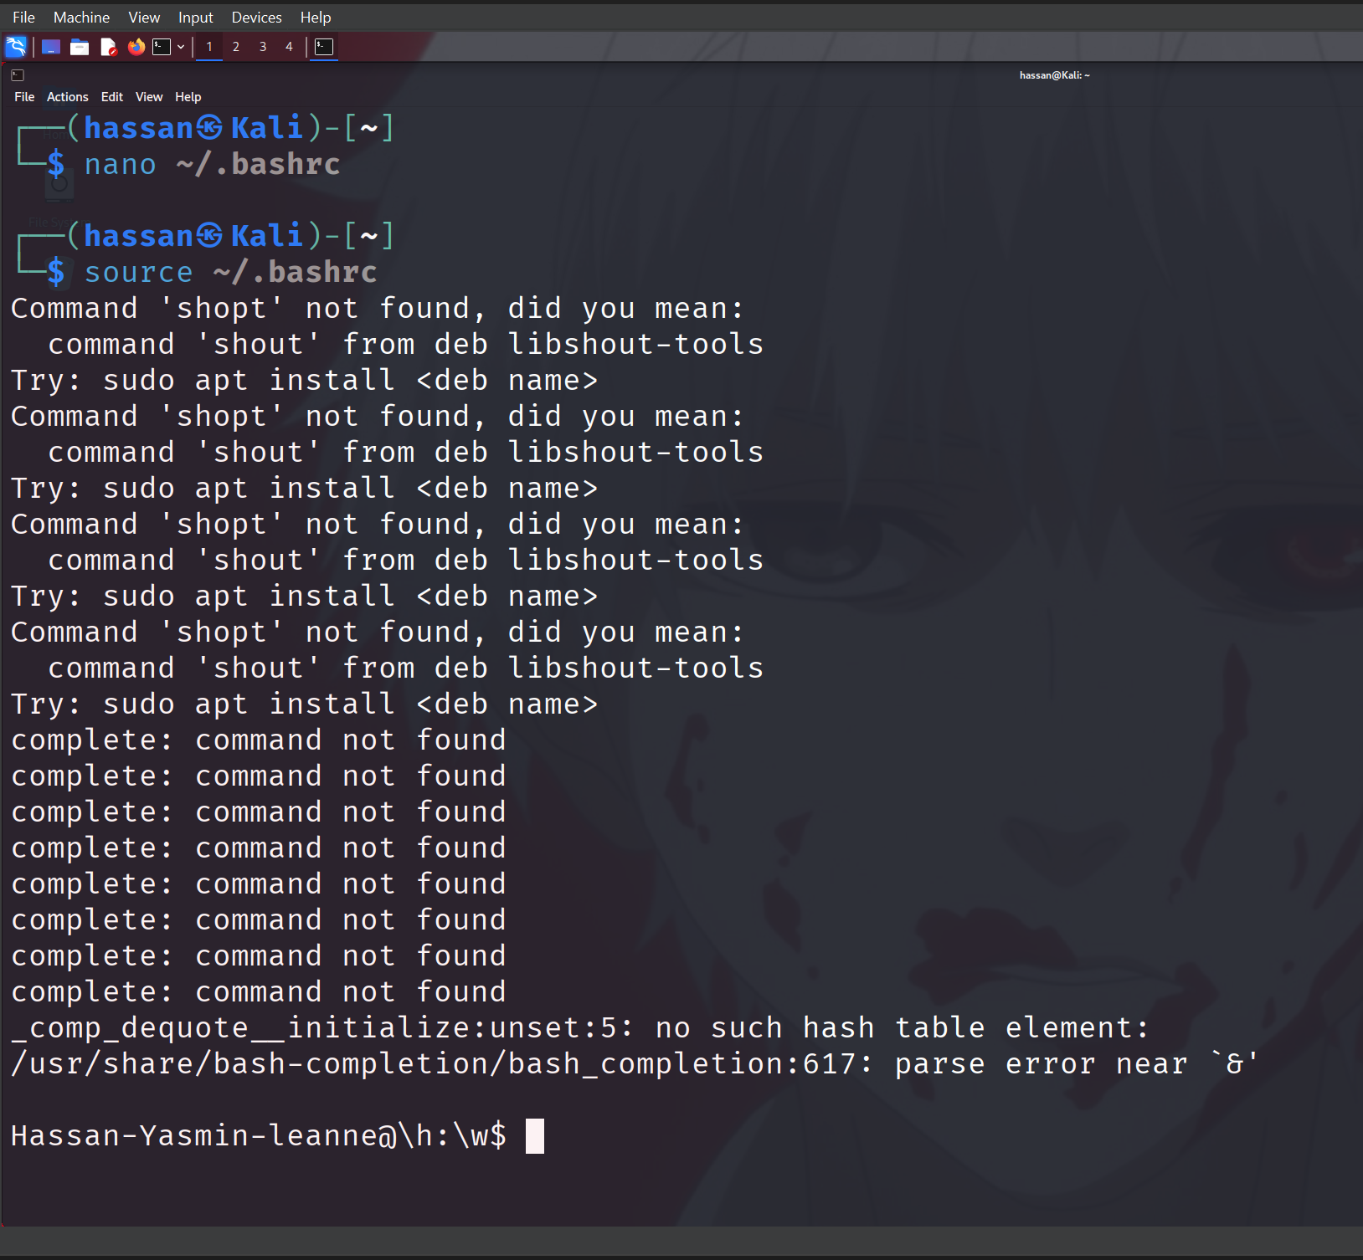

Module 1: Application of Cryptographic Techniques

Hassan 20220002085
Objective: Apply cryptographic techniques to secure sensitive data and messages using symmetric and asymmetric encryption methods. Students will encrypt, transmit, and decrypt data, while also exploring the implementation of TLS/SSL to protect web communication.

Detailed Overview
This module requires students to understand the basics of cryptography, experiment with both symmetric and asymmetric algorithms, and explore secure data transmission using TLS/SSL. Students will work with tools available in Kali Linux, such as OpenSSL, GPG, and SSH.

Task 1: Symmetric Encryption & Decryption

Objective: Securely encrypt and decrypt files using symmetric algorithms (e.g., AES or DES).
- Tools: OpenSSL, GPG
- Instructions:
  - Select a file of your choice (at least 500KB) to encrypt.
    - Use OpenSSL to encrypt the file using the AES-256 algorithm.
openssl enc -aes-256-cbc -in <input_file> -out <encrypted_file>.enc -k <password>

commands used:
wget https://images7.alphacoders.com/121/thumb-1920-1219983.png
openssl enc -aes-256-cbc -in thumb-1920-1219983.png -out encrypted_file.enc -k password
openssl enc -des-cbc -in thumb-1920-1219983.png -out encrypted_file_des.enc -k password
openssl enc -des-ede3-cbc -in thumb-1920-1219983.png -out encrypted_file_3des.enc -k password

Explore different encryption algorithms, such as DES and Blowfish, and compare encryption times and outputs.
    - Take a screenshot of the command and the encrypted output
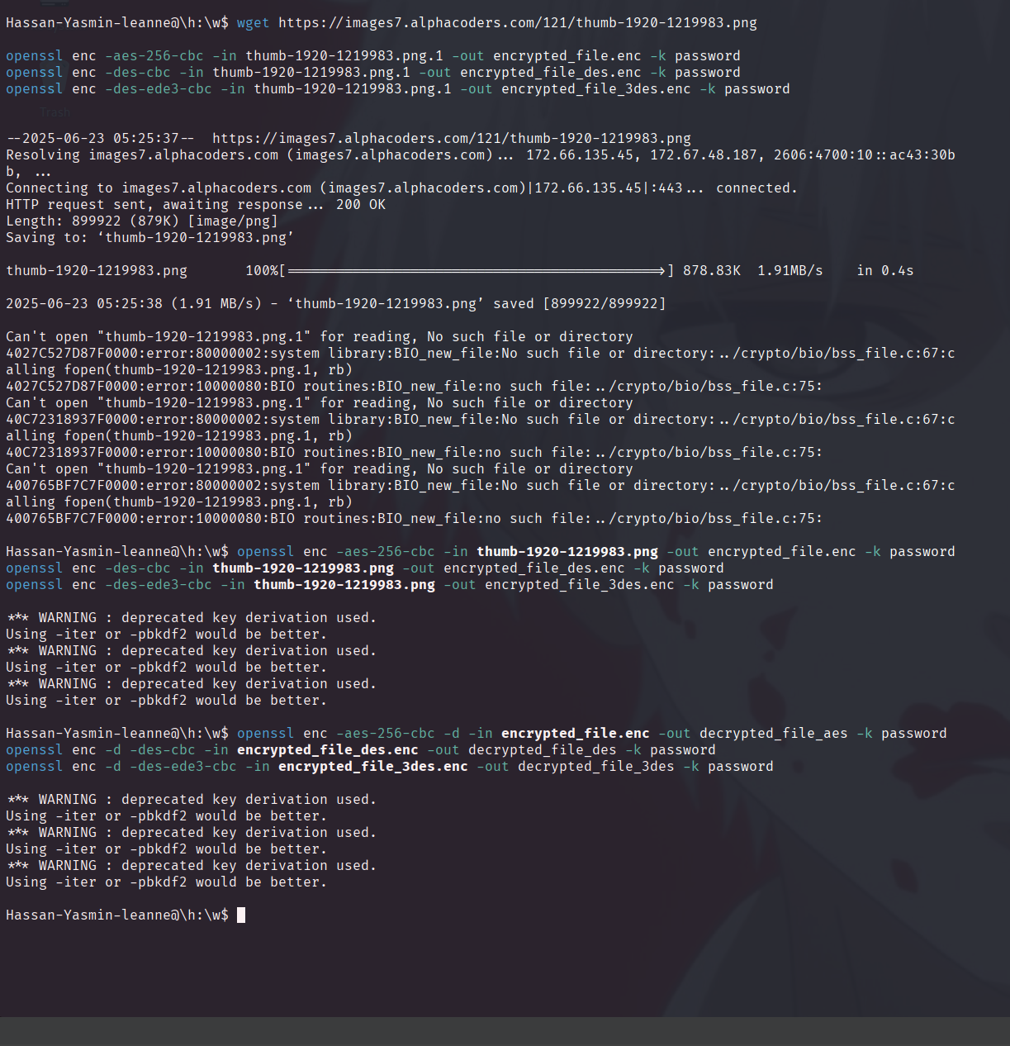

  - Decrypt the file using OpenSSL and verify its integrity.
openssl enc -aes-256-cbc -d -in <encrypted_file>.enc -out <decrypted_file> -k <password>

commands used:
openssl enc -aes-256-cbc -d -in encrypted_file.enc -out decrypted_file_aes -k password
openssl enc -d -des-cbc -in encrypted_file_des.enc -out decrypted_file_des -k password
openssl enc -d -des-ede3-cbc -in encrypted_file_3des.enc -out decrypted_file_3des -k password

    - Provide the decrypted file in the deliverables.

Gui proof of encryption and decryption working
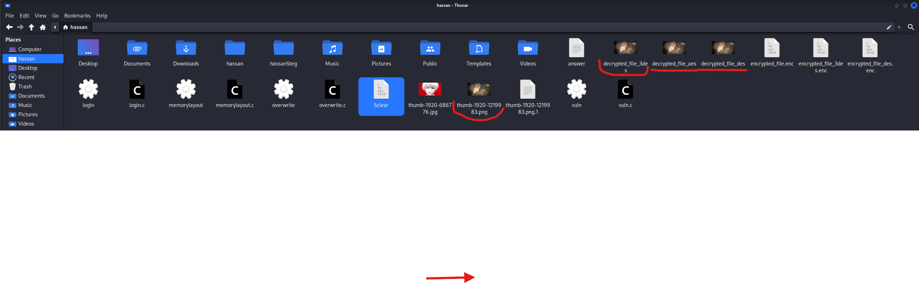
- Deliverables:
  - Encrypted and decrypted files.
  - A brief report describing the encryption algorithms used, the time taken for encryption/decryption, and any observations about their strengths or weaknesses.

- des is the fastest but least secure then aes 256 and most secure and lastly 3des slowest of all and is secure but not as secure as aes

Task 2: Asymmetric Encryption & Key Exchange
- Objective: Securely exchange data using asymmetric encryption and key pairs.
- Tools: OpenSSL, GPG
- Instructions:
  - Generate a pair of RSA keys (public and private keys) using OpenSSL or GPG.
    - OpenSSL command:
openssl genrsa -out private_key.pem 2048
openssl rsa -in private_key.pem -pubout -out public_key.pem
    - GPG command:
gpg --gen-key
  - Encrypt a sensitive message (at least 500 characters long) using the public key.
    - OpenSSL command:
openssl rsautl -encrypt -inkey public_key.pem -pubin -in <message_file> -out <encrypted_file>
  - Decrypt the message using the private key.
    - OpenSSL command:
openssl rsautl -decrypt -inkey private_key.pem -in <encrypted_file> -out <decrypted_file>
  - Exchange keys with a peer in your group, encrypt a file using the peer’s public key, and decrypt it using your private key.
  - Deliverables:
    - Public and private key files.

    - 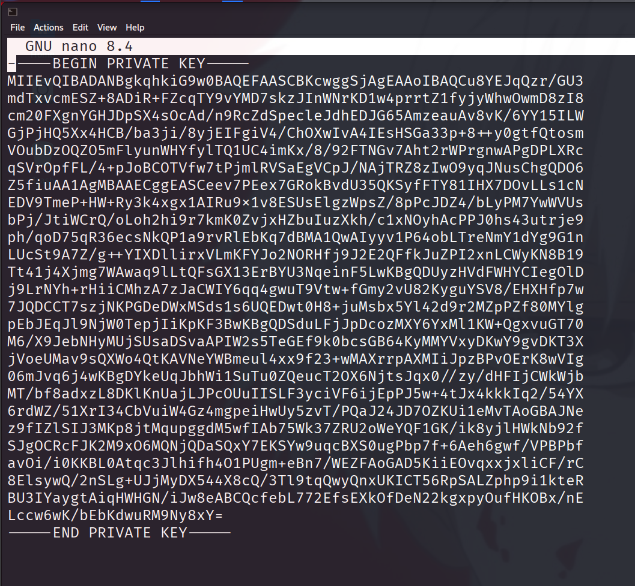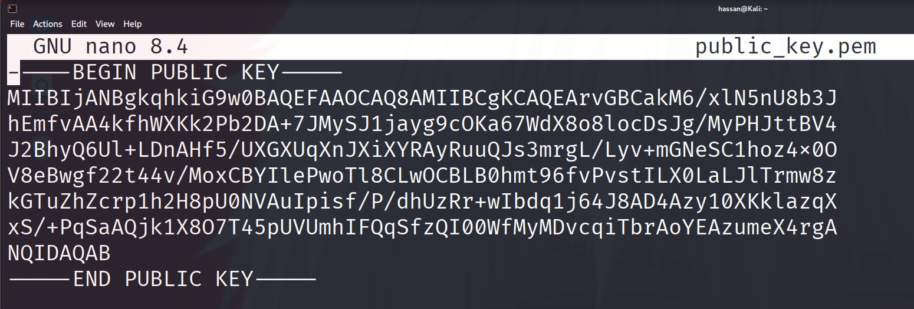
    - Encrypted and decrypted messages.

    - 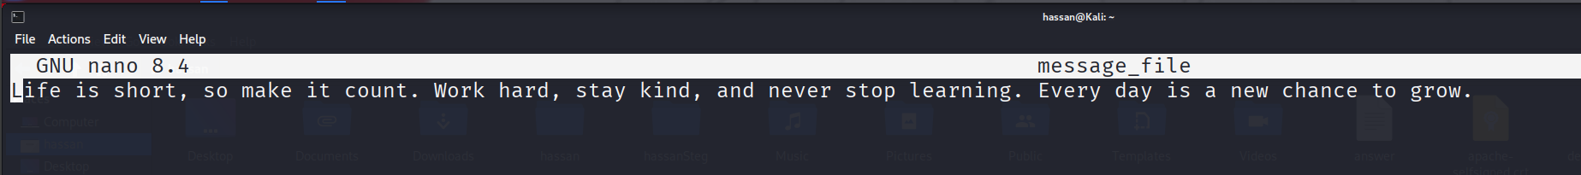
    - Screenshots of key generation, encryption, and decryption commands.
    - 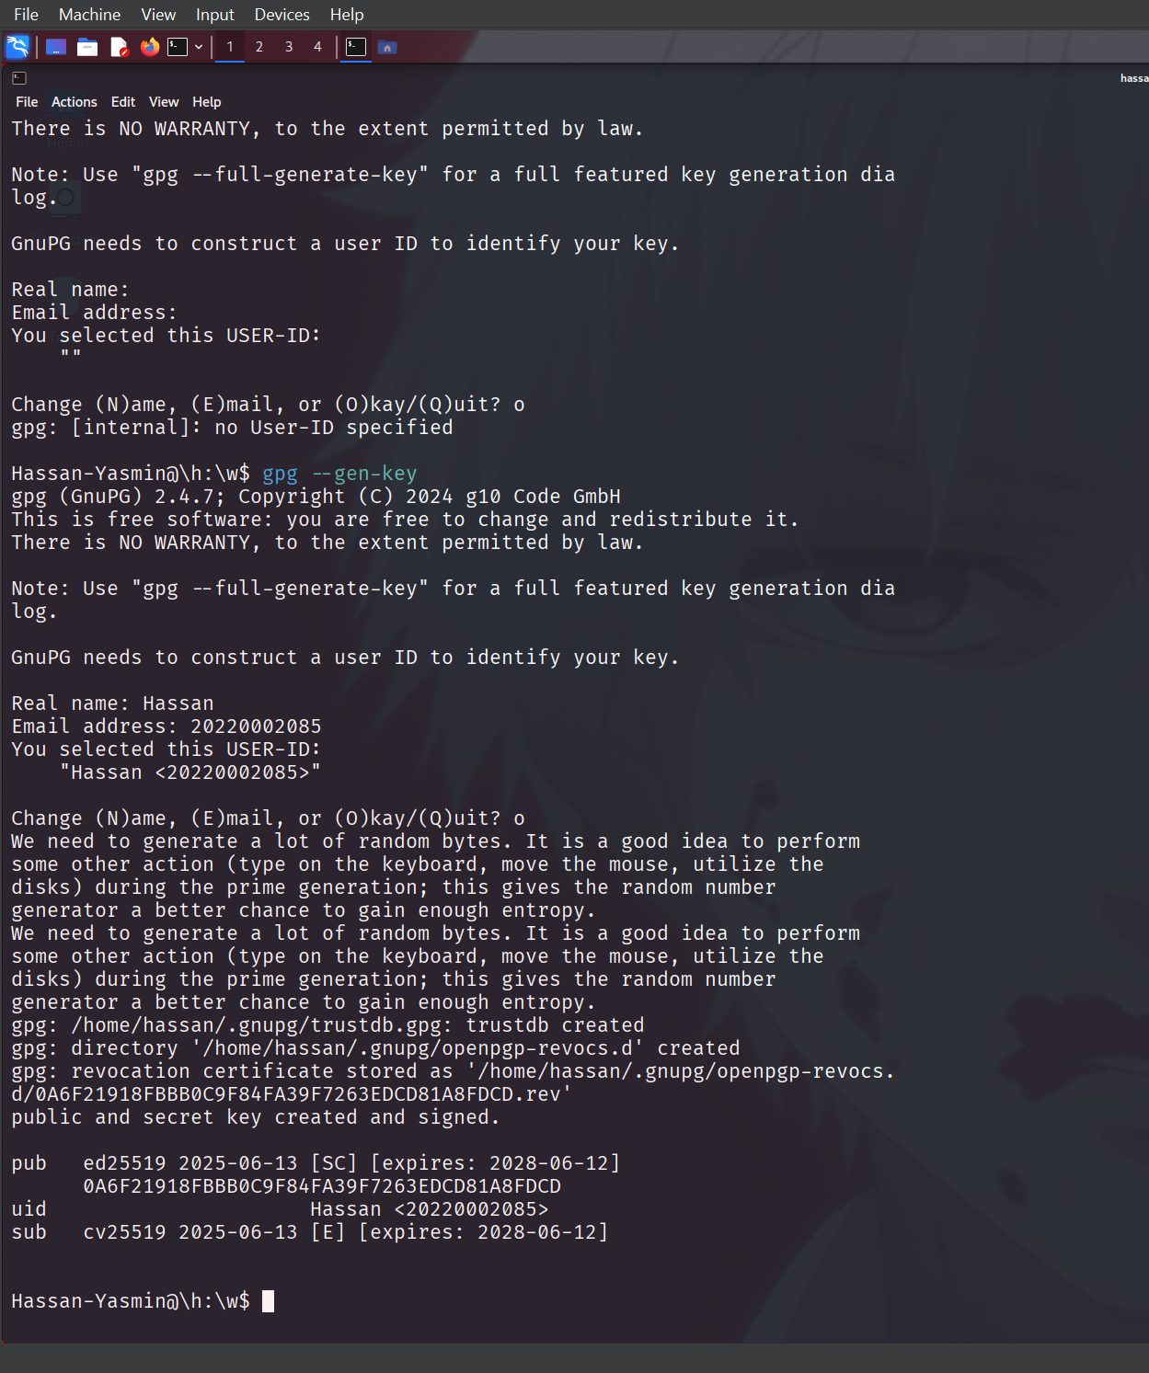

    - 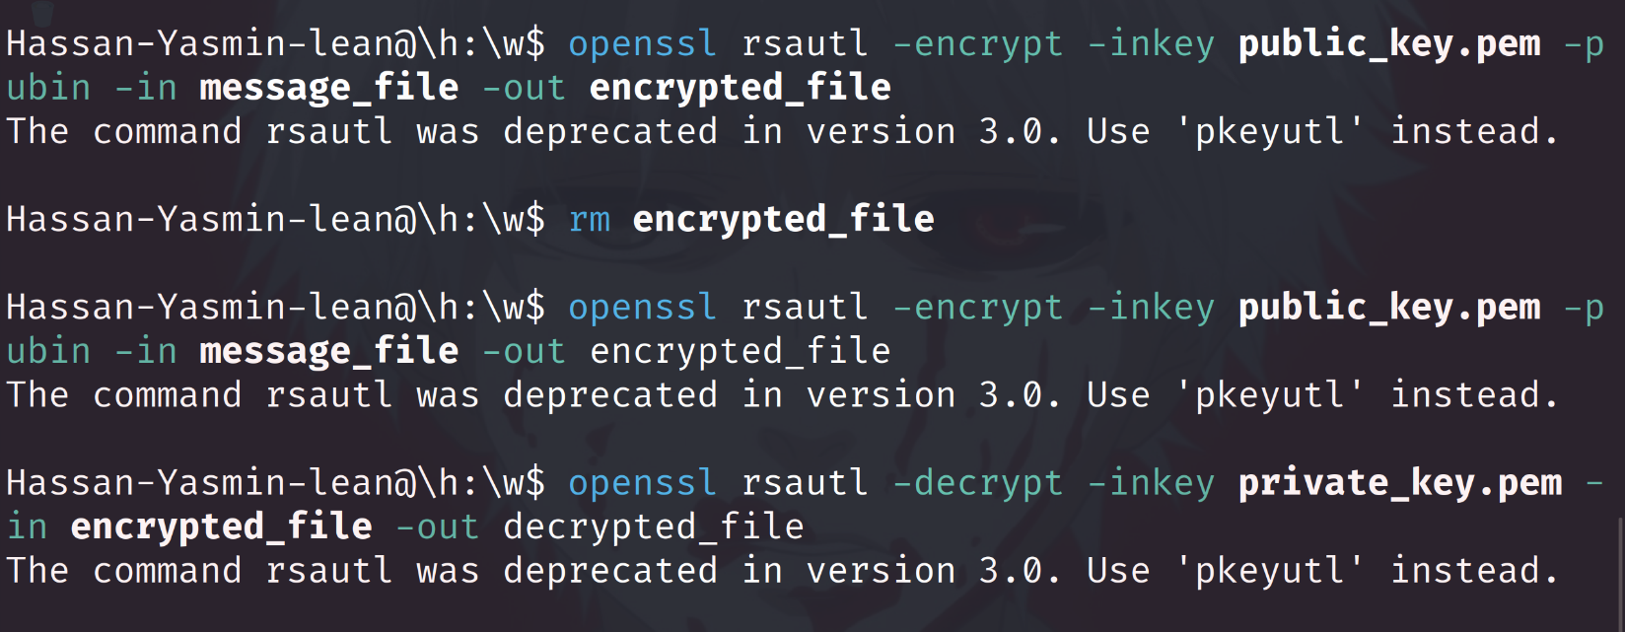 A report explaining the advantages of asymmetric encryption and the challenges of key management.
    - The encryption provides 2 keys private and public the private only the owner has while public key is shared with oother as it is used for only encryption so even of the hacker gets the key they cant decrypt the data

Task 3: Implementation of TLS/SSL for Secure Communication
- Objective: Implement TLS/SSL to encrypt data in transit.
- Tools: OpenSSL, Nginx (or Apache)
- Instructions:
  - Generate SSL/TLS certificates using OpenSSL.
openssl req -x509 -newkey rsa:2048 -keyout key.pem -out cert.pem -days 365
  - Set up a simple web server using Nginx or Apache, and configure it to use the generated SSL certificate. You can use any other tool.
    - Nginx configuration:
sudo nano /etc/nginx/sites-available/default
      - Add:
vbnet

server {
listen 443 ssl;
ssl_certificate /path/to/cert.pem;
ssl_certificate_key /path/to/key.pem;
...
}
  - Test the TLS/SSL connection by accessing the web server from another system using a browser.
  - Deliverables:
    - SSL certificates and configuration files.
    - 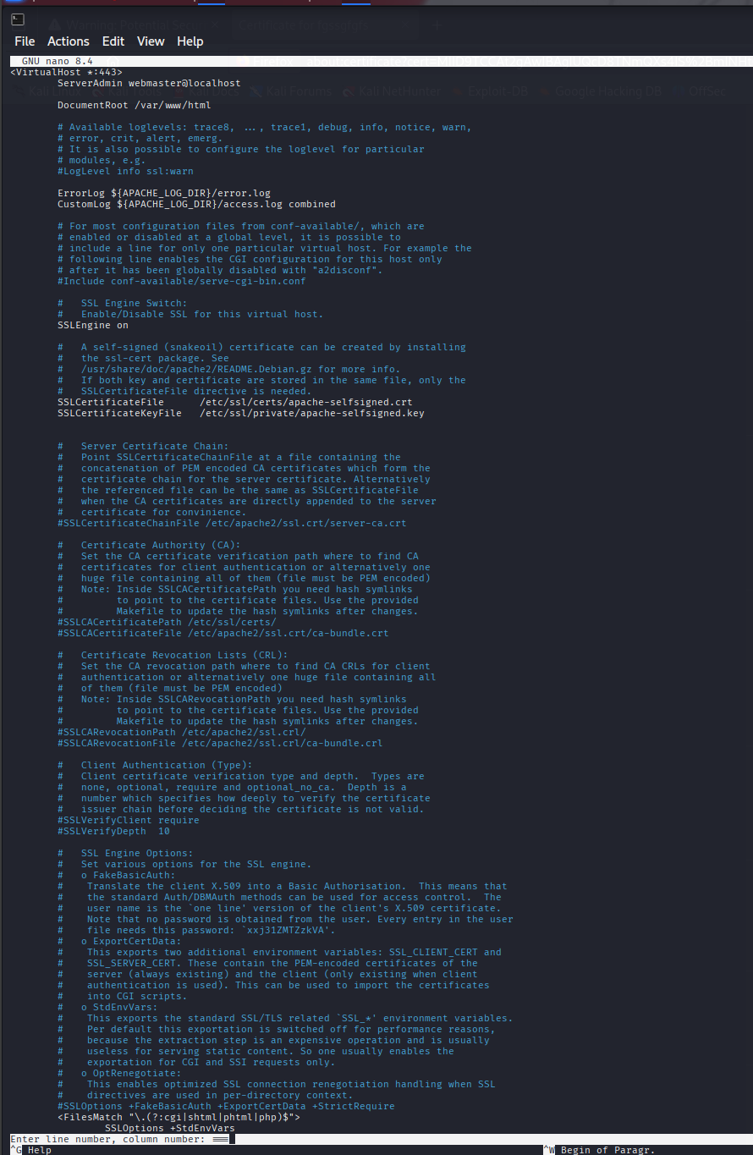
    - 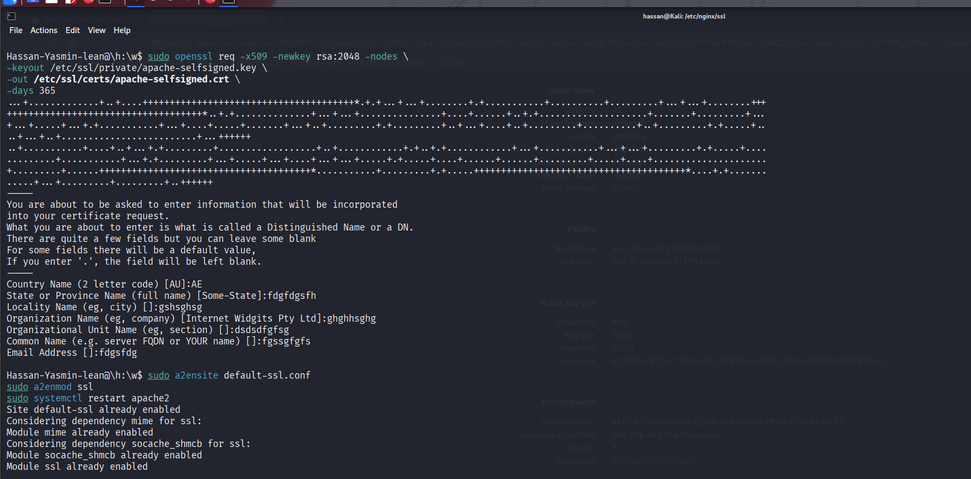
    - 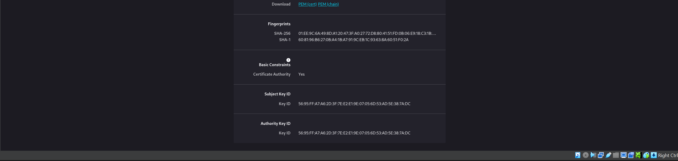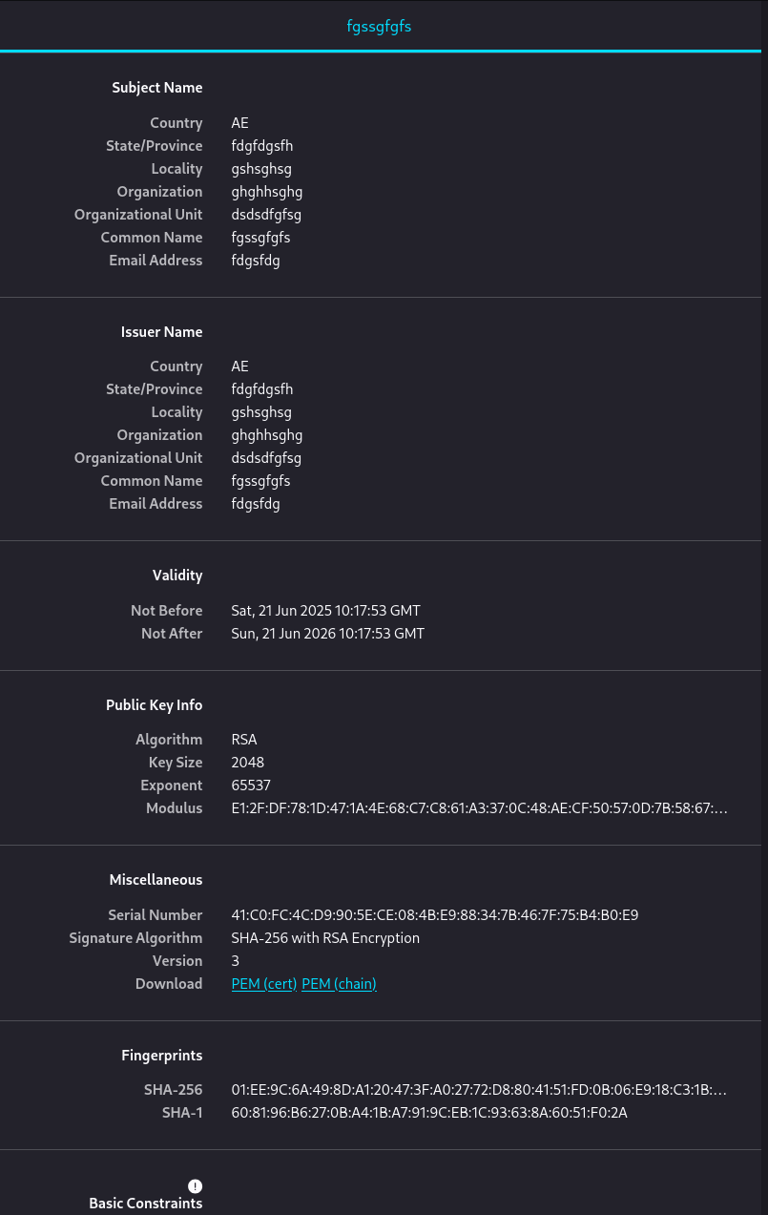
    - Screenshots of secure web connections with “https” in the URL bar.

    - 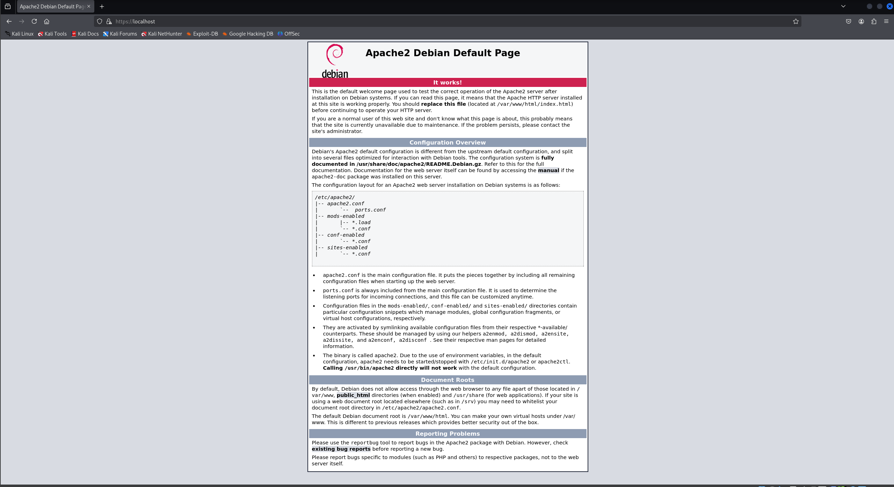
    - A report explaining the significance of TLS/SSL, focusing on how it prevents eavesdropping.
    - TLS and SSL protect data exchange between clients by encrypting information between server and client, so that the third party cannot access it nor change the data, preventing confidentiality and integrity. The TLS and SSL use handshake method to agree on an encryption key so that both parties can encrypt and decrypt the data, preserving the availability of it. This prevents any type of eavesdroppers to do anything.

Task 4: Ethical Implications of Cryptography

Objective: Reflect on the ethical considerations related to encryption, focusing on privacy, data protection, and responsible usage.
Instructions:
- Write a brief report (300-400 words) discussing the following points:
1 | The ethical use of encryption for data privacy and protection.  Answer:  Encryption is important when sending data like messages or files online. It makes sure only the person who’s supposed to see it can read it. For example, if you send a message, encryption turns it into code so no one else can understand it except the receiver. This helps keep your information private and safe from hackers or people trying to spy on you. Using encryption in a good way means protecting people’s personal stuff, not using it to hide bad things. It’s also important that companies and even the government don’t misuse it to watch people. Encryption is there to protect, not to control.
2 | How encryption can be used for malicious purposes (e.g., ransomware), and measures to prevent such misuse.  Answer: One of the most sneaky methods through which hackers infect ransomware is through Trojan horses. They tend to appear as regular appearing files or applications but when you open them or install them your entire system may freeze. Then a ransom note appears that the hacker will provide you with a decryption tool in exchange of money. To avoid this , all you can do is avoid suspicious websites and any link people can send you via text . Most of the time, that is how the infection enters. Just because the download appears to be helpful or some cracked app, do not download it unless you are sure that it is not a ploy to infect your computer. One is better safe than sorry.  having backup of your stuff can prevent this . Make sure that your important files are stored in different locations. Saving data in external hard drive can save you from a lot of trouble and also have backup in cloud . Then in case of anything going wrong, you will not lose everything. Imagine all your pictures, school assignments and valuable documents in jail and somebody is demanding money to open. Backs ups provide you with actual peace of mind. And in the process, make sure your computers security is up-to-date and your antivirus software is good. It will not intercept all the threats, but it assists. Long story short, do not trust suspicious downloads, keep your data stored in several locations and be cautious.
3 | The importance of balancing security with the right to privacy, especially in communication channels.  Answer:  Security is required so that the sensitive information between communication channels is not compromised and it also prevents someone from fabricating information between channels or changing it

Guidelines for Completing Module 1
- Students must use Kali Linux for completing all tasks, leveraging the pre-installed tools such as OpenSSL, GPG, and Nginx.
- Each student should encrypt different files, messages, and data to ensure originality.
- Key exchange among students must be documented, including a summary of the exchanged files.
Submission Requirements:
  - Encrypted and decrypted files for symmetric and asymmetric encryption.
  - A report for each task detailing processes, commands, outputs, and observations.
  - A reflective report on ethical implications.

Module 2: Defensive Security against Program & Web Threats

Leanne 20210001983
Objective: Implement defensive security measures against program-based threats, focusing on buffer overflow defense and Multi-Factor Authentication (MFA). Students will also analyze the ethical implications of these defensive security measures.
Detailed Overview
This module consists of hands-on tasks that involve implementing defenses against buffer overflow attacks and setting up MFA for secure remote access using SSH. It also includes a task related to the ethical implications of these measures.

Task 1: Buffer Overflow Analysis & Defense
- Objective: Simulate and defend against a buffer overflow attack using a simple C program.
- Tools: GDB, gcc, Python
- Instructions:
  - Create a simple C program with a buffer overflow vulnerability:
    - Students will write a basic C program with an overflow vulnerability:
#include <stdio.h>
#include <string.h>

void vulnerable_function(char *input) {
char buffer[10];
strcpy(buffer, input);
printf("Buffer: %s\n", buffer);
}
int main(int argc, char *argv[]) {
vulnerable_function(argv[1]);
return 0;
}
    - Compile the program without stack protection:
gcc -fno-stack-protector -o vuln vuln.c
  - Analyze the program using GDB:
    - Launch GDB and input a string longer than 10 characters to simulate a buffer overflow.
gdb ./vuln
      - Use commands like run <input> and info registers to observe changes in memory.
  - Implement basic buffer overflow defenses:
    - Modify the code to use strncpy() instead of strcpy() and add bounds checking:
strncpy(buffer, input, sizeof(buffer) - 1);
buffer[sizeof(buffer) - 1] = '\0';
    - Recompile the program and test it using GDB to ensure that overflow is prevented.
  - Deliverables:
    - Original and modified C programs.
    - 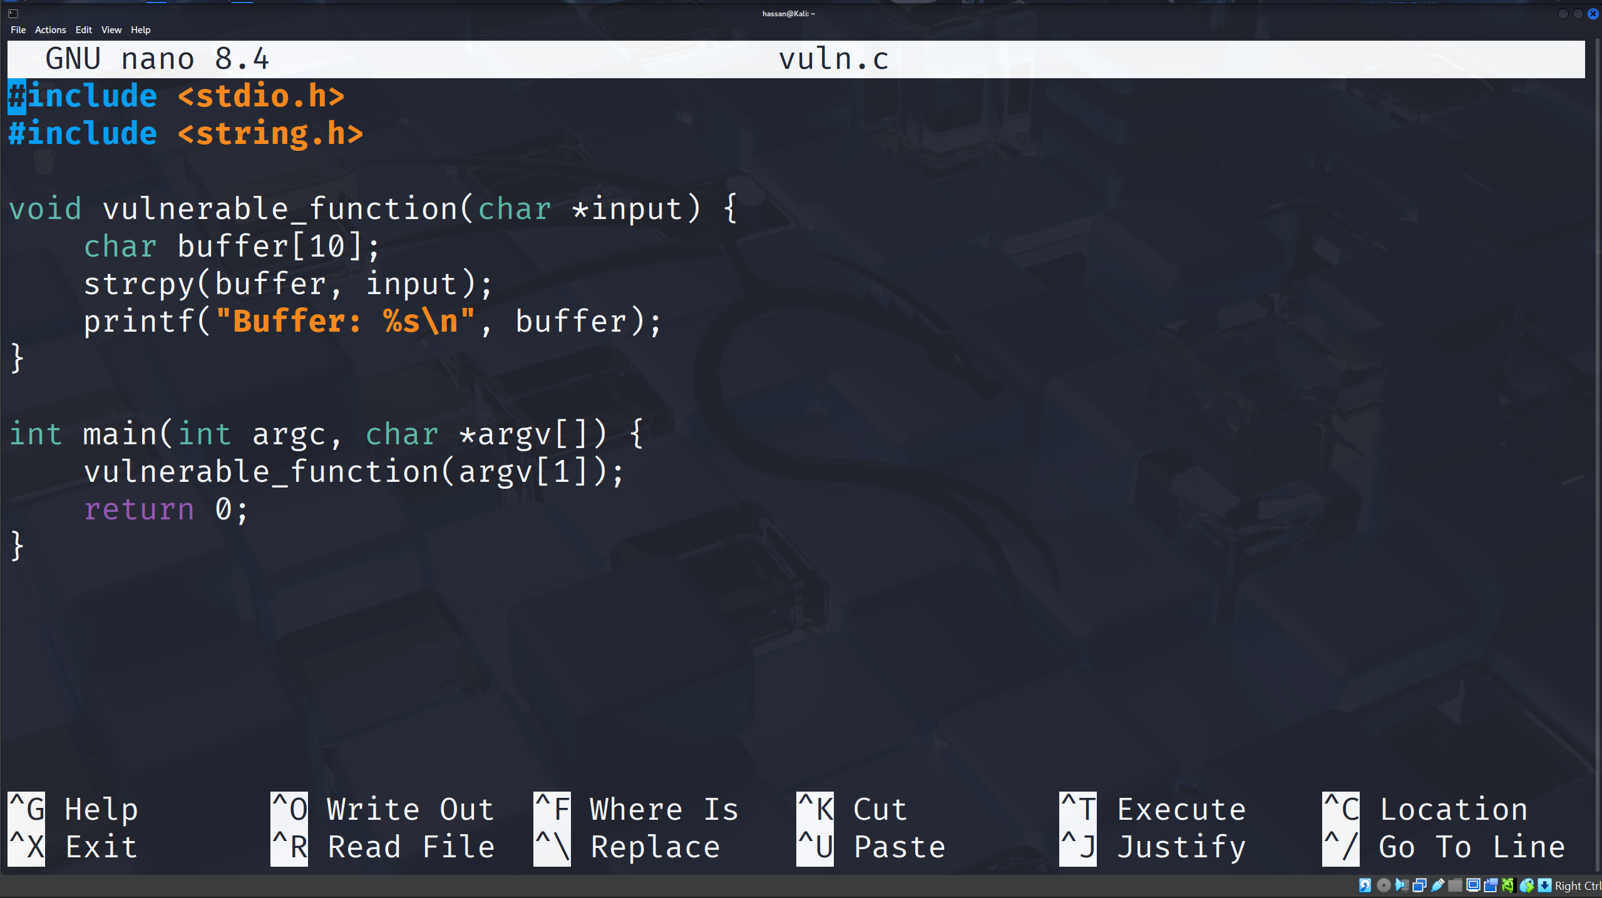
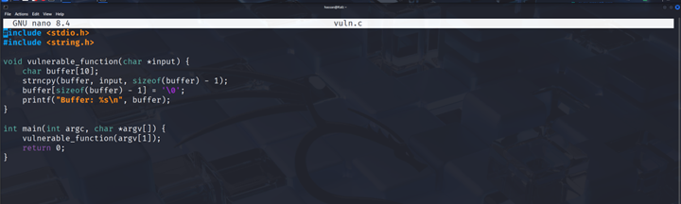

- GDB output showing overflow before and after mitigation.
Before mitigation :
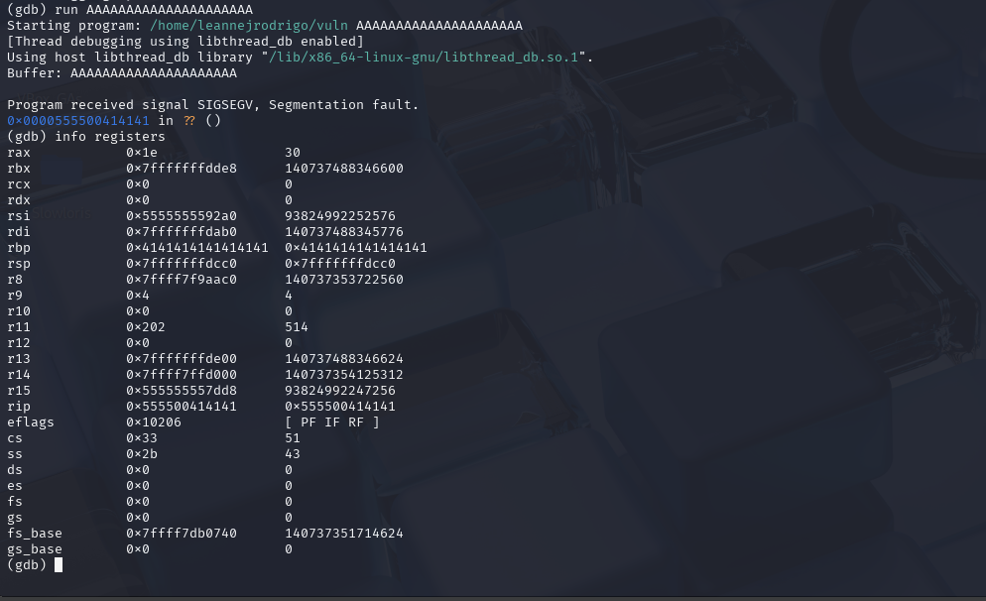
After mitigation:
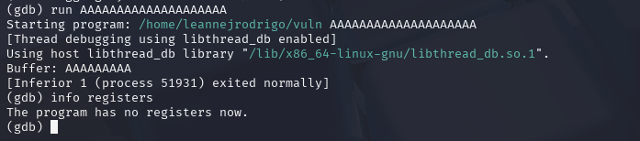

    - A short report explaining how the buffer overflow was detected and mitigated.
- A C application that was purposefully created with a buffer overflow vulnerability was used in this lab. By entering more data than the program's buffer could handle, the vulnerability was discovered. The program produced a segmentation error, indicating that memory had been overwritten, when it was executed in GDB with a lengthy input.
- We discovered unexpected values in crucial registers like the instruction pointer and base pointer by using GDB's register inspection feature. This verified that there had been a buffer overflow, which might be used to change the control flow of the program.
- The code's vulnerable section was changed to provide appropriate bounds checking in order to lessen the problem. The overflow was avoided and the application ran securely without crashing when the revised version was recompiled and run. This proved that the buffer overflow vulnerability was successfully prevented by the mitigation.

Task 2: Multi-Factor Authentication (MFA) Setup using SSH
- Objective: Set up and test MFA for secure SSH access using Google Authenticator and SSH on Kali Linux.
- Tools: SSH, Google Authenticator app
- Instructions:
  - Install Google Authenticator on Kali Linux:
    - Install the PAM module for Google Authenticator.
sudo apt install libpam-google-authenticator
google-authenticator
    - Follow the prompts to set up Google Authenticator, generate a QR code, and scan it using the Google Authenticator app on your smartphone.
  - Configure SSH to use MFA:
    - Open the SSH configuration file using a text editor:
sudo nano /etc/ssh/sshd_config
    - Enable Challenge-Response Authentication by finding and modifying the following line:
ChallengeResponseAuthentication yes
    - Add Google Authenticator to the PAM configuration for SSH:
sudo nano /etc/pam.d/sshd
      - Add this line at the end of the file:
auth required pam_google_authenticator.so
    - Restart the SSH service to apply changes:
sudo systemctl restart sshd
  - Connect to the Kali Linux machine using SSH from another device:
    - Open a terminal on another device and use SSH to connect:
ssh <username>@<Kali_IP>
    - Enter the Google Authenticator code generated on your phone when prompted.
  - Explore additional MFA setups:
    - Use other MFA options such as text-based tokens, one-time passwords (OTPs), or even hardware-based keys if available.
  - Deliverables:
    - Screenshots of the SSH connection process, MFA prompts, and successful login.

Generated Emergency Codes:
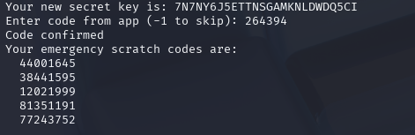
SSH connection , MFA prompt and successful login:
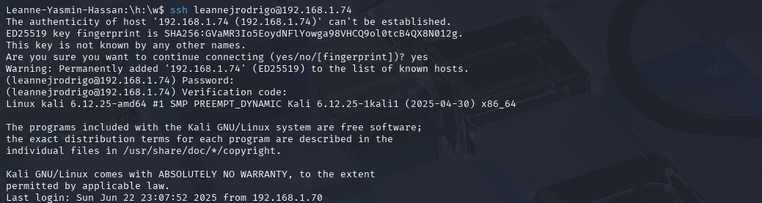

    - A brief report explaining how MFA enhances security and its effectiveness.
    - In the lab Multi-Factor Authentication (MFA) on Kali Linux SSH access application was configured through Google Authenticator. When the needed PAM module was installed and the configuration of the SSH altered, the system was set up to request the user their password and a verification code generated by the Google Authenticator mobile app. This verification code is a one-time password which is time based (TOTP) since it refreshes itself every 30 seconds. A list of the emergency scratch codes was also developed during setup. They serve as a backup of the mobile device as a login in case the mobile device was not available. Due to demanding two forms of authentications, MFA is highly effective in enhancing security:
    - A password that you know is your SSH password.
    - Something physical you possess such as scratch codes or the Authenticator app
    - This means that in the absence of the second one even in the situation whereby a users password has been hacked it is impossible to have any unwarranted access. Parting all things considered, MFA enhances the safety of the systems and reduces the chances of remote attacks to a significant extent.

Task 3: Ethical Analysis of Buffer Overflow Defense and MFA
- Objective: Reflect on the ethical implications of implementing defenses like buffer overflow protection and MFA.
- Instructions:
  - Write a brief report (300-400 words) covering:
1 | The importance of securing programs against buffer overflow to protect user safety and trust.  Answer: Buffer overflow flaws grant amount of power to the hackers so that they can write over the memory and this may lead to program crash or unauthorised access. Avoiding the major threats, users will prevent penetration of systems and stealing of information. It also creates confidence since individuals rely on software to secure their information. To prevent these flaws, developers should resort to safe coding methods that ensure reliable and secure solutions are offered.
2 | The ethical considerations of implementing MFA, especially related to user convenience and privacy.  Answer: MFA can enhance security since it involves more than one authentication factor; however, it might undermine the user privacy and convenience. To avoid unfair taxation or the exclusion of its consumers, it is morally paramount to create a compromise between a strong level of security and usability. The privacy and access needs of the users are addressed when using an accessible and transparent data collection where back-ups, like emergency codes, are availed.
3 | How the use of defensive measures aligns with professional responsibilities and legal compliance.  Answer: In order to safeguard users and develop trustworthy programs, professional ethics promotes the application of the security measures such as the buffer overflow protection and multi-factor authentication. Also, it contributes to legal safe access and data protection requirements in laws like GDPR. To avoid hurting people, to avoid being on the wrong side of the law, and to meet their duty as professionals towards their consumers and society in general, professionals need to embrace some defences.

- Submission Requirements:
  - Screenshots and output from SSH and GDB tasks.
  - Modified code and configurations with defensive measures.
  - A reflective report on ethical considerations.

Module 3: Operating System Security and Firewall Settings [5 marks] Yasmin 20230003798
Objective: Enhance system security by hardening the operating system and configuring firewall rules using iptables to protect against network threats and unauthorized access.

Overview
This module guides students through securing a Linux system by implementing multiple defensive measures. The module is designed to help students understand system vulnerabilities, configure effective firewall rules, and apply best practices for securing operating systems. It will require students to install, configure, and test firewall rules, ensuring complete protection of a Linux server.

Task 1: Linux System Hardening
- Install and run Lynis to perform a system audit, identifying potential vulnerabilities in the Linux operating system.
sudo apt install lynis
sudo lynis audit system
- Analyze the results of the audit report, focusing on:
  - File permissions and ownership issues
  - Unused services and open ports
  - Configuration issues with system files (e.g., /etc/passwd, /etc/shadow)
- Implement security recommendations suggested by Lynis, such as:
  - Disabling unused services (e.g., FTP, Telnet).
sudo systemctl disable ftp
  - Enforcing secure file permissions.
sudo chmod 600 /etc/shadow
- Deliverables:
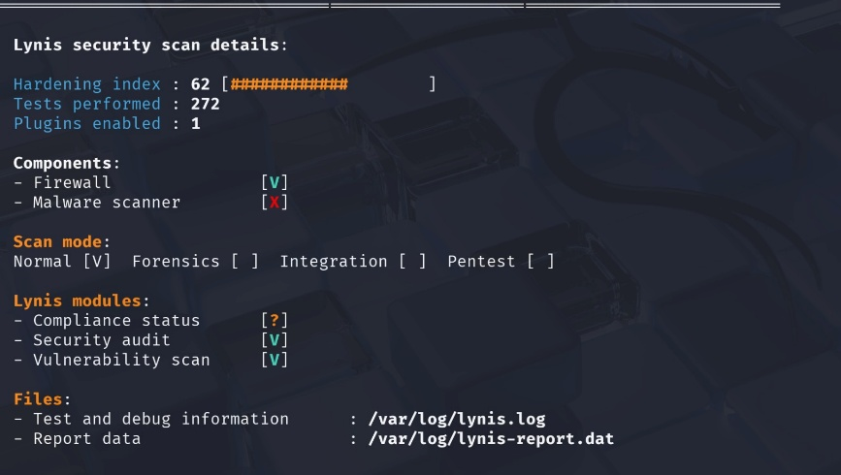
  - Lynis audit report before and after hardening.

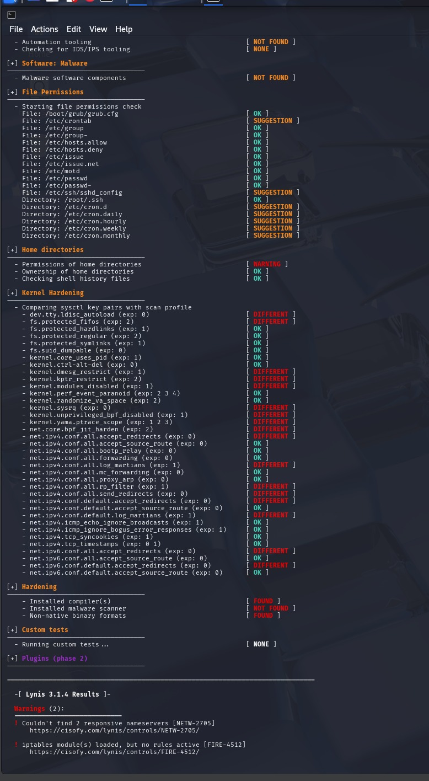
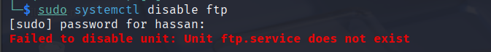
  - 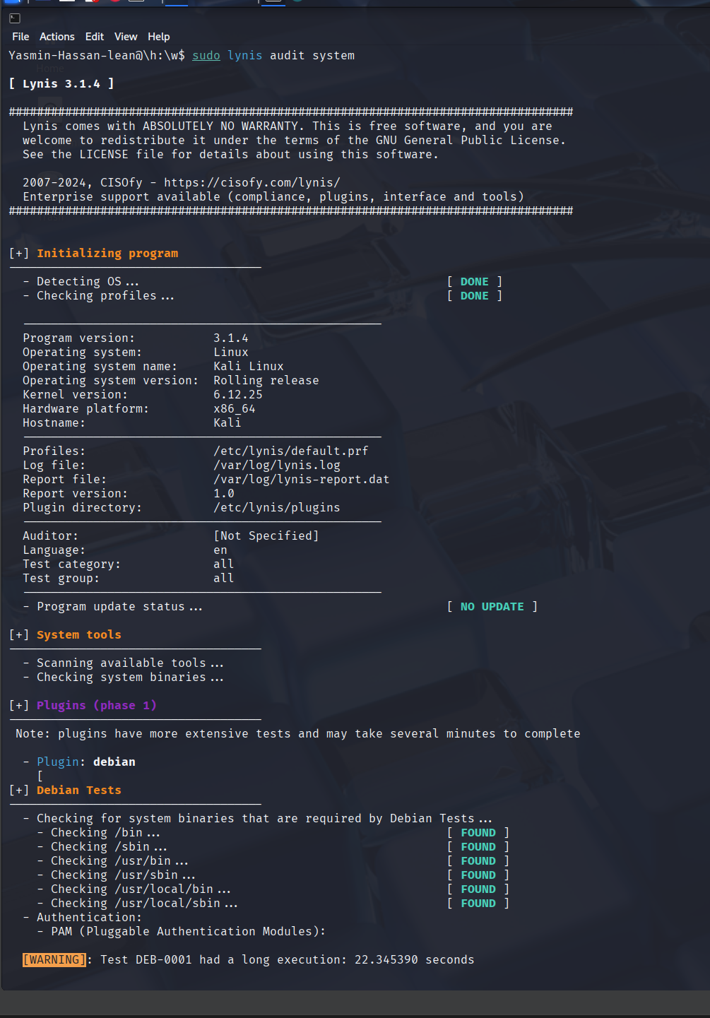
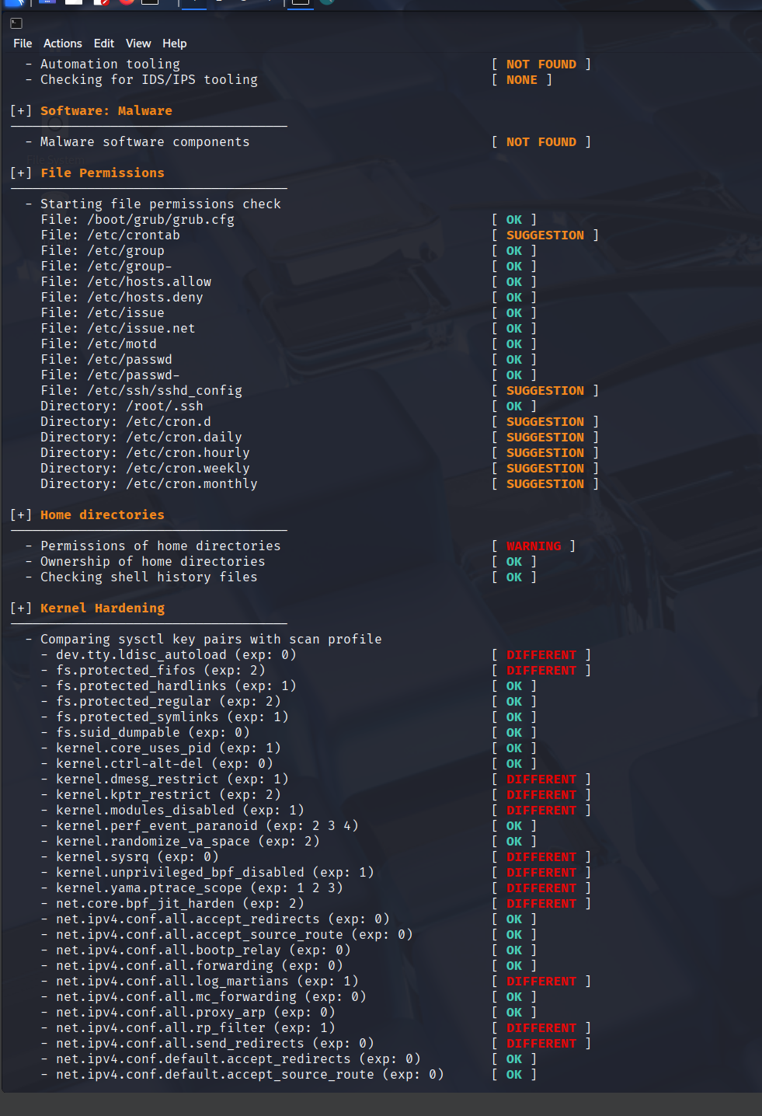
  - A brief analysis of the vulnerabilities found and the corrective measures implemented. 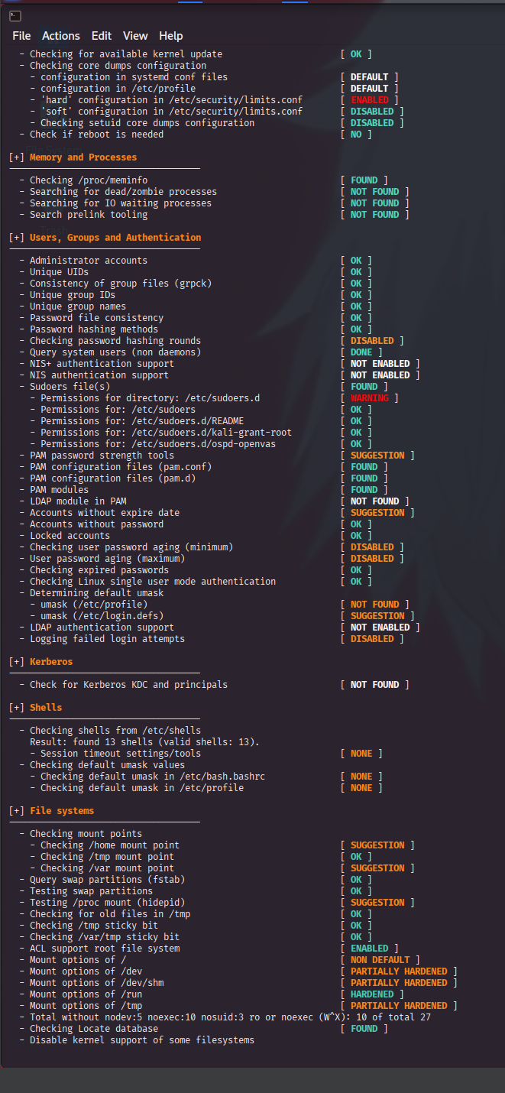

Task 2: Advanced Firewall Configuration with iptables and Implementing Dynamic Blocked list
This task requires students to implement and test comprehensive firewall rules using iptables to protect a Linux server. Moreover, you have to implement a dynamic blocked list where you will download a list of IP addresses and block all of them via IPTABLES.
Read this article: Implementing a Dynamic Blocklist with IPtables

Detailed Instructions
- Install iptables (if not already installed):
sudo apt install iptables
- Flush existing rules and set default policies to DROP:
  - Set default rules to prevent unauthorized access to the system.
sudo iptables -F
sudo iptables -P INPUT DROP
sudo iptables -P FORWARD DROP
sudo iptables -P OUTPUT DROP
  - Explanation: This step ensures that only the specified traffic is allowed, providing a strong defensive measure against unauthorized access.
- Implement Specific Firewall Rules:
  - Allow SSH connections from specific IP addresses only (e.g., 192.168.1.10):
sudo iptables -A INPUT -p tcp --dport 22 -s 192.168.1.10 -j ACCEPT
    - Explanation: This rule restricts SSH access to a specific IP, ensuring secure remote management.
  - Allow web server traffic (HTTP/HTTPS) on ports 80 and 443:
sudo iptables -A INPUT -p tcp --dport 80 -j ACCEPT
sudo iptables -A INPUT -p tcp --dport 443 -j ACCEPT
    - Explanation: These rules enable access to web services hosted on the server while maintaining other restrictions.
  - Block access from a specific IP address (e.g., 192.168.1.50) to prevent potential attacks:
sudo iptables -A INPUT -s 192.168.1.50 -j DROP
- Logging and Monitoring Firewall Activity:
  - Enable logging for dropped packets:
sudo iptables -A INPUT -j LOG --log-prefix "IPTABLES-DROP: "
    - Explanation: This rule logs dropped packets, allowing you to monitor suspicious traffic and take appropriate action.
- Testing and Validation:
  - Use netcat to test access to the configured ports and verify that the firewall rules work as intended:
    - To test allowed access (e.g., port 22):
nc -zv <server_ip> 22
    - To test blocked access (e.g., IP 192.168.1.50):
nc -zv <server_ip> 22 -s 192.168.1.50
    - Explanation: The use of netcat confirms whether specific ports are accessible or blocked based on the implemented firewall rules.
- Deliverables:
  - iptables configuration file: Showcasing all implemented rules.
  - Logs: Demonstrating blocked attempts and allowed access.
  - Final Report: Detailing:
    - Configuration steps and command outputs.
    - An analysis of the effectiveness of the implemented rules.
    - Ethical considerations related to firewall use and monitoring.
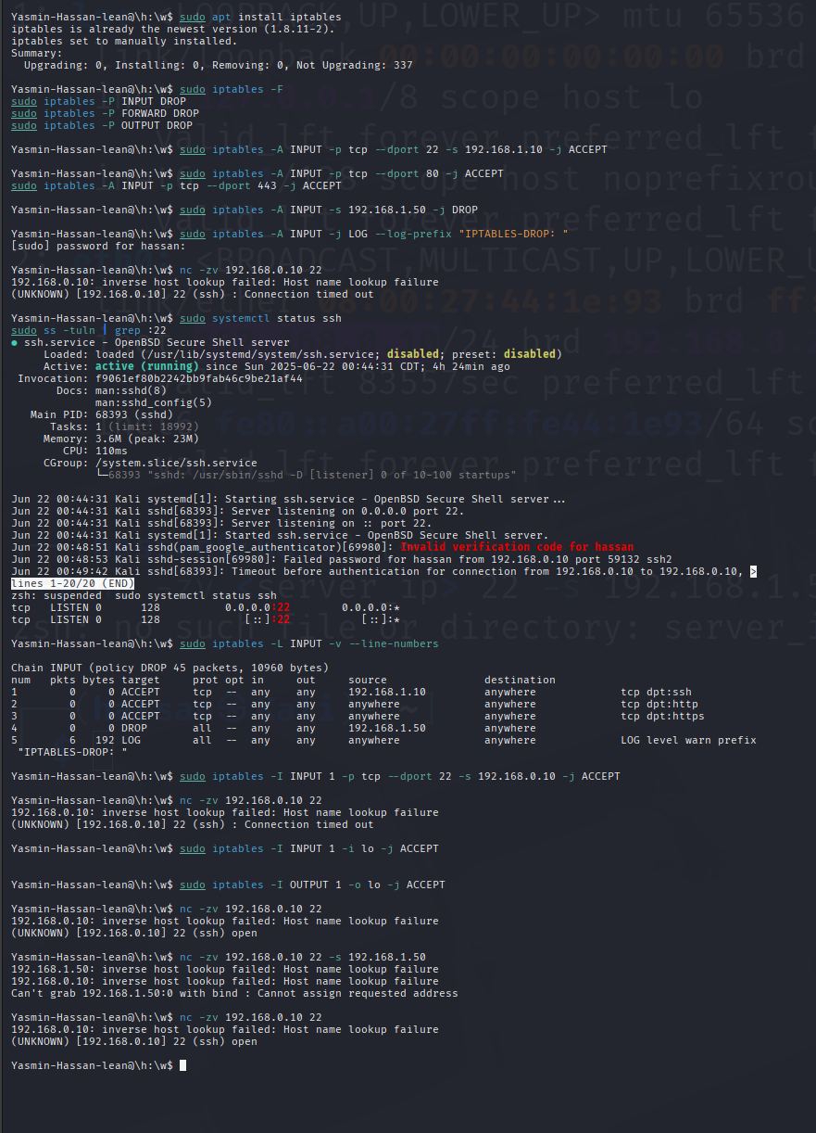
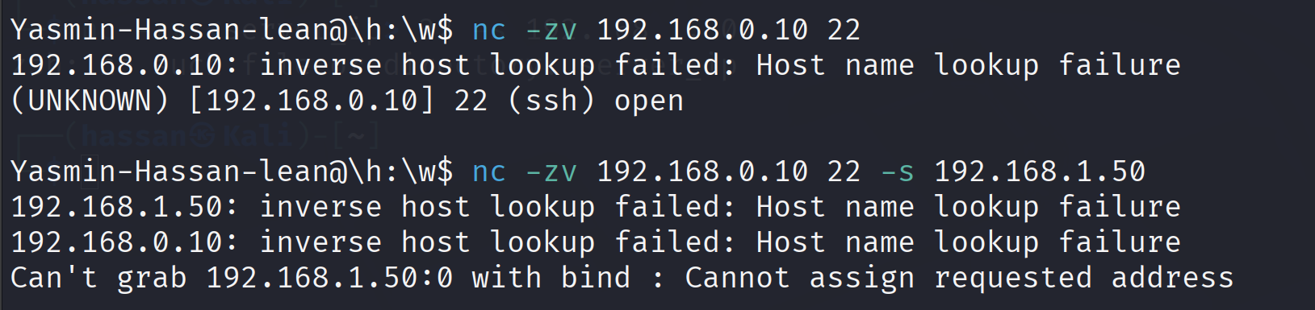
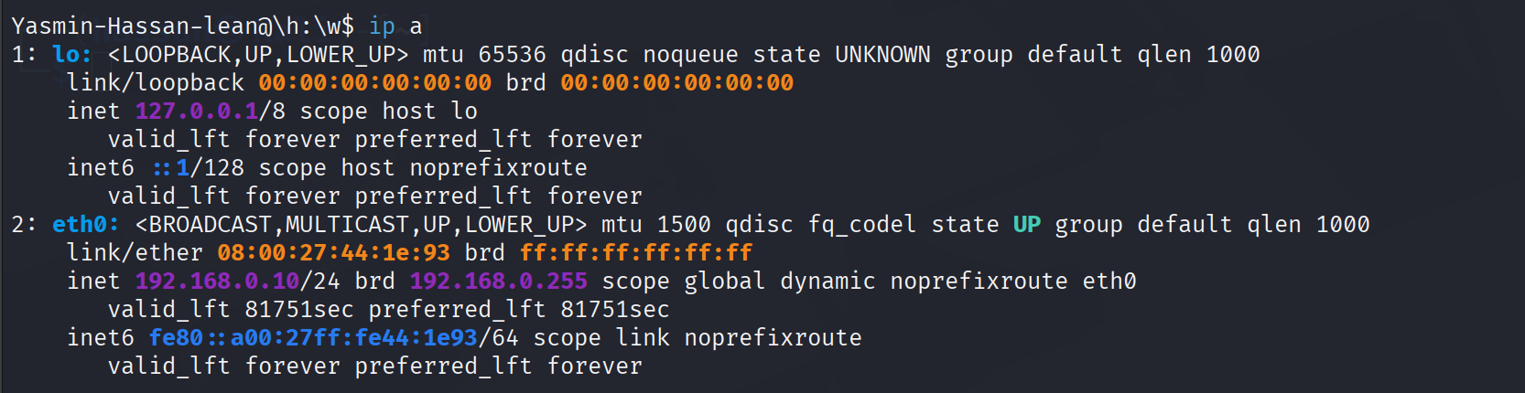
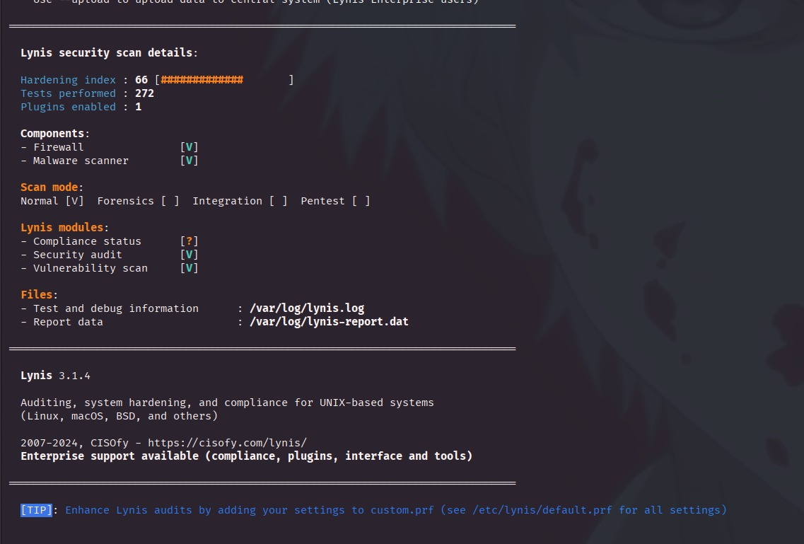

As there were some warnings pop up every now and then we decided to download and implement an anti virus on Kali Linux’s VM using the following steps:

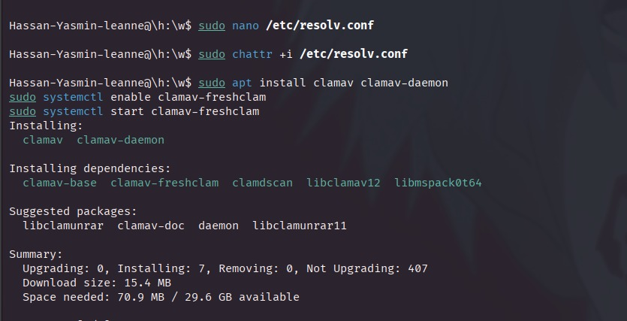

Guidelines:

Start with system hardening using Lynis to identify weaknesses. Ensure to implement at least three critical recommendations from the audit report.
- Configure iptables step-by-step, following the instructions carefully.
- Test firewall configurations thoroughly using netcat or any other tool provided in the module.
- Document every step, including commands used, their purpose, and observed outcomes. Your final report should include screenshots, logs, and explanations of implemented security measures.
- Write a note on the ethical implications of using firewalls, especially when monitoring network activity.

Module 3 Documentation:
sudo lynis audit system
- A command that shows the system’s security details.
Traffic Control:
The following commands stop all outgoing and incoming connections
sudo iptables -P INPUT DROP
- We configured our iptables so that any traffic coming from the internet(network) towards our virtual machine to be blocked for reaching.
sudo iptables -P FORWARD DROP
- Any traffic coming from the external network and going to another network is to be blocked. Meaning no two or more computers can be connected to send data between them (our VM being one of them).

sudo iptables -P OUTPUT DROP
- Any traffic going from our virtual machine to the internet is to be blocked and inaccessible.

(Note that our project does not mention clarification on what we are securing and from what so we don’t know what traffic we need to allow in or to from our machine so to keep it as secure as possible we just blocked all type of traffic from entering)

sudo systemctl disable ftp
Used this command to disable ftp services (third command in module 3)

sudo chmod 600 /etc/shadow
This command secures the file containing the password so nobody but the owner (us) can read, write, or execute it.

sudo apt install clamav clamav-daemon
- Installs the antivirus scanner and its background daemon
sudo systemctl enable clamav-freshclam
- Sets automatic virus definition updates on system startup
sudo systemctl start clamav-freshclam
- Starts updating virus definitions immediately

Ethical Implications:
- While monitoring is often justified for security and compliance, it can lead to privacy concerns, especially if users are unaware that their activity is being tracked. Organizations must find a balance between their security requirements, all the while respecting their clients' privacy, ensuring that their supervision does not affect their mutual trust nor does it weaken their monitoring quality .Additionally there is always the risk of misuse or overreach, where adding too much security can lead to a drop in efficiency leading to a loss in precision and the exclusion of sensitive information. There is also the problem of keeping unauthorized logs of users without their consent due to miscommunication between the machine and the users or misconfigured machinery, so it is ethically very important that any monitoring done by the firewalls is transparent, clearly communicated and within the legal frameworks.
In summary, the ethical utilization of security and firewalls heavily depend and cannot/shouldn't exist without important ethical considerations such as: transparency, necessity, minimal invasiveness, and adherence to the user's privacy rights and legal standards.

